Cycle User Guidance Form
Please see the below guidelines for usage of these specialised bikes. Please familiarise yourself with the info for the cycle you intend to use in order to get maximum enjoyment and safety from the experience. If in any doubt or you are using the item of equipment for the first time ask a member of staff for assistance.
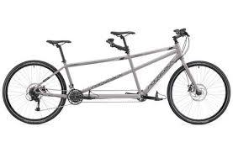  Tandem Bike | • Communication between pilot (front seat) & Stoker (back seat) is crucial for safe cycling. Whoever sits at front must be a confident cyclist.  • The pilot should hold the brakes firmly when stoker is getting on the bike.  • The pilot must not stop pedalling suddenly without telling the stoker as knees may be jarred.  • Dialogue and communication is key to safe tandem cycling.
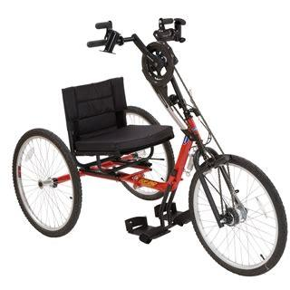  Hand Cycle | • The main hazard around the hand cycle is the high position of the chain and chain rings. Be careful with loose clothing such as scarves/ties etc.  • Stability is key when using this bike – any three wheeler if used recklessly can tip – be careful turning corners at speed.
Trike Cycle  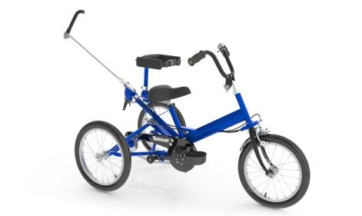 | • Stability is key when using this bike – any three wheeler if used recklessly can tip – be careful turning corners etc!  • The adult trikes are equipped with a parking brake lever which should be applied when getting on and off, particularly on a gradient, the trike will roll otherwise.  • A carer or guardian can also steer the bike from behind using the lever that is show on the picture to the left.
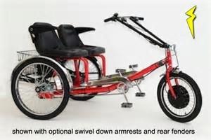 | - Side by side feet forward tandem where users can operate independently of each other unlike a conventional tandem bicycle. So one can pause pedalling or select a different gear independently of their buddy.  - Apply parking brake prior to mount & dismount, raise armrest and push handlebar away to ease access. Once seated adjust seat for & aft to avoid overstretching legs. Release parking brake and away you go!  - Pause pedalling momentarily when changing gear, hub gears are unlike derailleur gears where rotation must be maintained during gear shift.  - Gentle movement of the handlebar for turning, the steering is sensitive and unnerving if pushed excessively. Braking is done by rotating pedals backwards. If in doubt seek assistance.
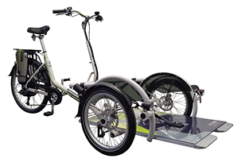 | - This wheelchair carrying tricycle must be demonstrated by a member of staff to first time users – the safe loading, securing and unloading of the wheelchair user is paramount – if unsure don’t.  - Ensure both parking brakes are applied prior to loading & unloading.  - Release split pin and platform release lever to tilt down, reverse user onto platform fully until wheels touch the buffers, apply your chairs brakes. The platform will tilt level and click securely as the chair loads. – The chair must be in the correct position for the correct centre of gravity - The platform release lever and it’s split pin must returned.  - All three harnesses must be hooked onto the chairs frame, one applies tension fore and two aft – when correctly secured and tensioned and the chairs own brakes applied the chair will not move. Release using the red latch and then tension by turning the knob on each ratcheted anchor point. If in doubt seek assistance.  - To unload simply reverse the procedure. Don’t forget to remove the platform release lever split pin and release the platform, as the wheelchair user rolls forwards slightly the platform will gently tilt down .
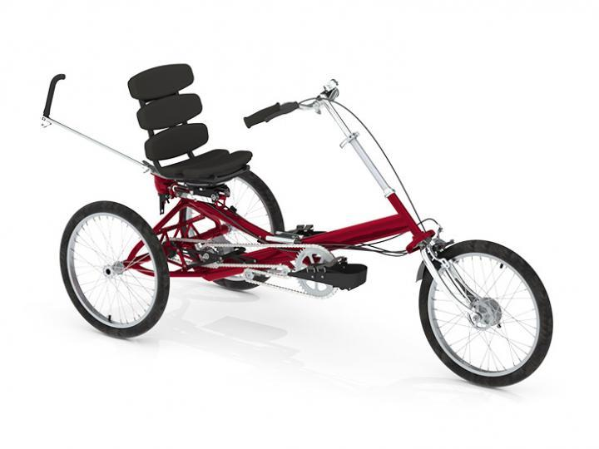 | - Ensure parking brake applied before mounting and dismounting.  - The unique function of the rotating seat enables ease of mount and dismounting, simply press the red lever on the left handlebar to release – Ensure the seat clicks back securely into position. The fore & aft seat position is adjustable by releasing the lever behind the seat to avoid overstretching legs.  - Handlebars are adjustable but forearms will usually have a slight upwards position when gripping the bars but seek assistance if in doubt regards seat and handlebar positioning.  - Pause pedalling momentarily when changing gears, hub gears are unlike derailleur gears where rotation is maintained during hear shifting.
BIKE HIRE AGREEMENT

I have inspected the bicycle(s) prior to signing this agreement and have checked they are in a satisfactory and safe condition and fit for purpose. We will not undertake any manoeuvre which is beyond our level of skill or unsuitable for the bikes capability. I fully indemnify Northern Community Leisure Trust against injury to myself or any third party. For those visually impaired users, we ask that you must have a secondary user with sufficient vision to operate the bike safely. I accept that cycle helmets have been offered and should I decide not to use them then I accept full responsibility. I have inspected the helmets & equipment prior to signing this agreement for any defects or damage. I recognise that cycling can be dangerous and acknowledge the risks involved.

Pilot Signature:_____________________________ Date:____________________________________

Pilot Name:________________________________

